2014-15

pritesh gandhi

rohit salpe

Randhir reddy

Merriest College Database User’s Guide

**About This Guide**

This Guide is for administrators and users of Merriest College Database which explains how to get the required information.

The following related documents for Merriest College Database are available:

* User’s guide which describe the basic operations that can be done on the database.
* Instructions on how to get the information for a particular faculty or particular department or particular student by executing the appropriate query with the appropriate input.
* Instructions on how to insert, delete and update the information.
* Instructions for displaying the predefined reports.

|  |  |
| --- | --- |
| Chapter 1 General Navigation Information …………………….. | 3 |
| Chapter 2 Forms …………………………………………………. | 5 |
| Chapter 3 Queries ………………………………………………… | 14 |
| Chapter 4 Reports ………………………………………………… | 24 |
|  |  |
|  |  |

**Table Of Contents**

**Chapter 1 General Navigation Information**

1. **Opening the database:**

* For opening the database, the user has to just double click on the database file.
* When the database opens then the user is automatically navigates to the main menu through which the desired operations can be performed.

1. **Main Menu Form:**

* In this form, the user will be provided options or buttons through which he can navigate to the desired form or report. As shown in the figure below, there are three important parts: Tables, Queries & Reports. The user has to select the desired option and click the button given in front of it. This will open the form corresponding to that query, report or table.

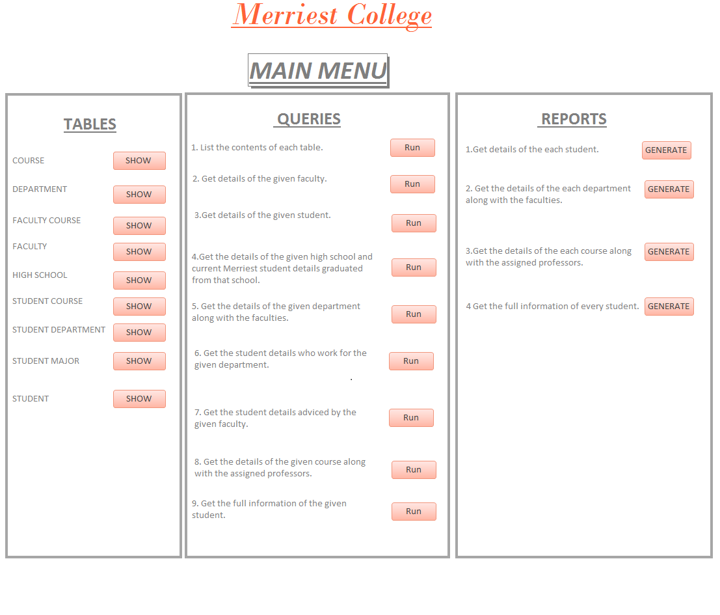

1. **GOTO MAIN MENU BUTTON :**

* Every form or report in this application has this button as shown in the picture below.
* Whenever the user desires to navigate to another form or report then he has to click on this button first given at the bottom of the current form.
* The user will go to the main form from where the user can select the required form or report.

1. **Exit Button :**

* If the user wants to exit or close the entire database then the user has to click a cross button as shown in the figure below on the right-top corner of the current form.



* When the user clicks on this button the whole application exits.

**Chapter 2 Forms**

1. Course form.

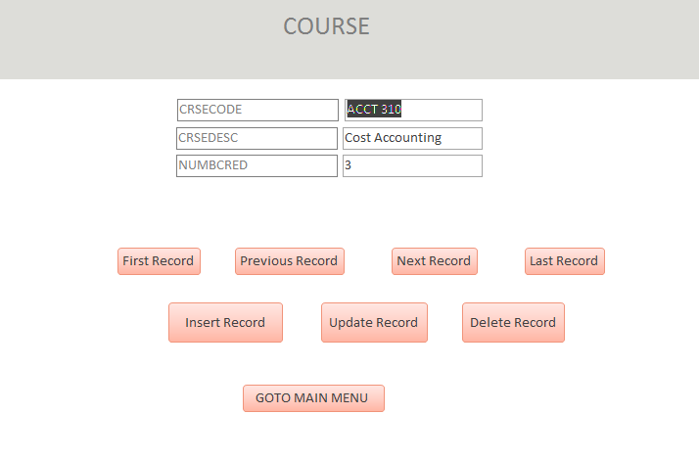

On this form, the user can perform the following operations:

* Navigate to the next, previous, first and last record.
* Insert, update or remove the course.
* Also when the user clicks on the GOTO MAIN MENU button then he can goto the main menu form.
* For inserting the record, the user has to first click the insert button which clears all the fields. After that the user has to enter the new values & click the insert record button again.
* For updating the record, the user has to make sure that the record to be update is displayed in the fields then the user can update the information & click the Update record button.
* For deleting the record, the user has to make sure that the record to be deleted is displayed in the fields then the user can delete the information by clicking the Delete record button.

1. Department form.

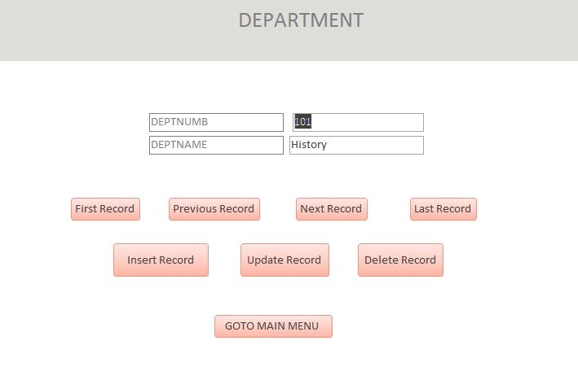

On this form, the user can perform the following operations:

* Navigate to the next, previous, first and last record.
* Insert, update or remove the department.
* Also when the user clicks on the GOTO MAIN MENU button then he can goto the main menu form.
* For inserting the record, the user has to first click the insert button which clears all the fields. After that the user has to enter the new values & click the insert record button again.
* For updating the record, the user has to make sure that the record to be update is displayed in the fields then the user can update the information & click the Update record button.
* For deleting the record, the user has to make sure that the record to be deleted is displayed in the fields then the user can delete the information by clicking the Delete record button.

1. Faculty course form.

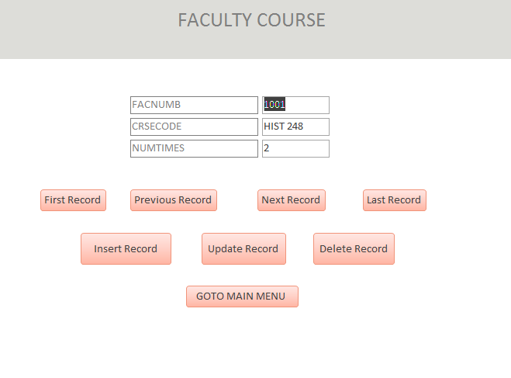

On this form, the user can perform the following operations:

* Navigate to the next, previous, first and last record.
* Insert, update or remove the faculty & the related course.
* Also when the user clicks on the GOTO MAIN MENU button then he can goto the main menu form.
* For inserting the record, the user has to first click the insert button which clears all the fields. After that the user has to enter the new values & click the insert record button again.
* For updating the record, the user has to make sure that the record to be update is displayed in the fields then the user can update the information & click the Update record button.
* For deleting the record, the user has to make sure that the record to be deleted is displayed in the fields then the user can delete the information by clicking the Delete record button.
* **NOTE** : If the faculty record in faculty table or course record in the course table is deleted then the all the records in faculty course related to that record will also be deleted (called cascade).

1. Faculty form.

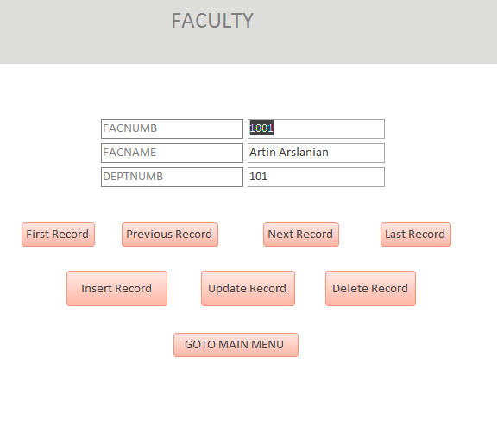

On this form, the user can perform the following operations:

* Navigate to the next, previous, first and last record.
* Insert, update or remove the faculty.
* Also when the user clicks on the GOTO MAIN MENU button then he can goto the main menu form.
* For inserting the record, the user has to first click the insert button which clears all the fields. After that the user has to enter the new values & click the insert record button again.
* For updating the record, the user has to make sure that the record to be update is displayed in the fields then the user can update the information & click the Update record button.
* For deleting the record, the user has to make sure that the record to be deleted is displayed in the fields then the user can delete the information by clicking the Delete record button.

1. High school form.

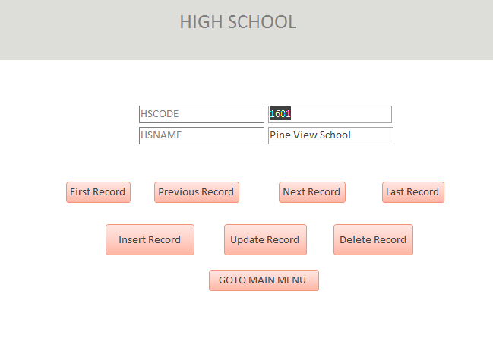

On this form, the user can perform the following operations:

* Navigate to the next, previous, first and last record.
* Insert, update or remove the high school.
* Also when the user clicks on the GOTO MAIN MENU button then he can goto the main menu form.
* For inserting the record, the user has to first click the insert button which clears all the fields. After that the user has to enter the new values & click the insert record button again.
* For updating the record, the user has to make sure that the record to be update is displayed in the fields then the user can update the information & click the Update record button.
* For deleting the record, the user has to make sure that the record to be deleted is displayed in the fields then the user can delete the information by clicking the Delete record button.

1. Student Course form.

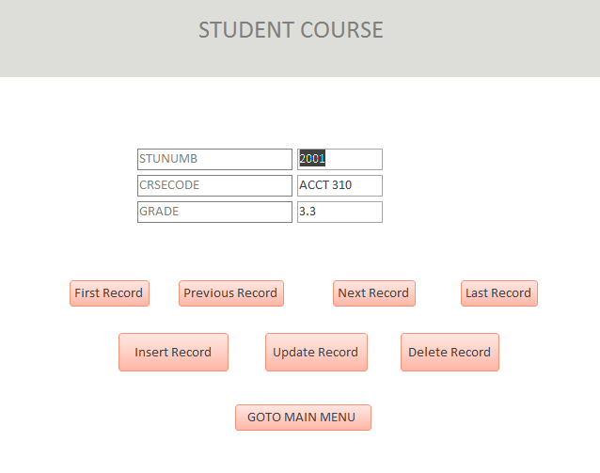

On this form, the user can perform the following operations:

* Navigate to the next, previous, first and last record.
* Insert, update or remove the student & the related course.
* Also when the user clicks on the GOTO MAIN MENU button then he can goto the main menu form.
* For inserting the record, the user has to first click the insert button which clears all the fields. After that the user has to enter the new values & click the insert record button again.
* For updating the record, the user has to make sure that the record to be update is displayed in the fields then the user can update the information & click the Update record button.
* For deleting the record, the user has to make sure that the record to be deleted is displayed in the fields then the user can delete the information by clicking the Delete record button.
* NOTE: A student record cannot be deleted if he is referenced here.

1. Student Department form.

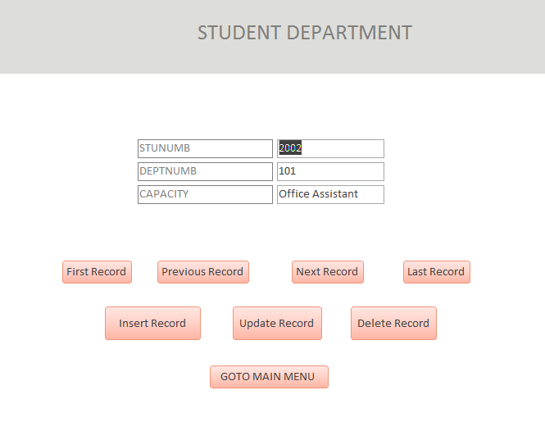

On this form, the user can perform the following operations:

* Navigate to the next, previous, first and last record.
* Insert, update or remove the student & the related department.
* Also when the user clicks on the GOTO MAIN MENU button then he can goto the main menu form.
* For inserting the record, the user has to first click the insert button which clears all the fields. After that the user has to enter the new values & click the insert record button again.
* For updating the record, the user has to make sure that the record to be update is displayed in the fields then the user can update the information & click the Update record button.
* For deleting the record, the user has to make sure that the record to be deleted is displayed in the fields then the user can delete the information by clicking the Delete record button.
* **NOTE** : If the student record in student table or department record in the department table is deleted then the all the records in student department related to that record will also be deleted.

1. Student Major form.

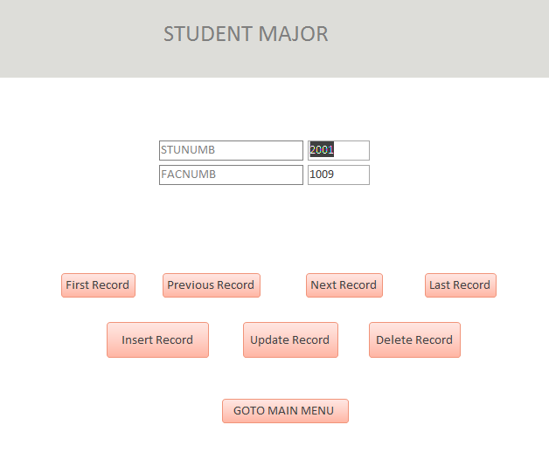

On this form, the user can perform the following operations:

* Navigate to the next, previous, first and last record.
* Insert, update or remove the student’s major.
* Also when the user clicks on the GOTO MAIN MENU button then he can goto the main menu form.
* For inserting the record, the user has to first click the insert button which clears all the fields. After that the user has to enter the new values & click the insert record button again.
* For updating the record, the user has to make sure that the record to be update is displayed in the fields then the user can update the information & click the Update record button.
* For deleting the record, the user has to make sure that the record to be deleted is displayed in the fields then the user can delete the information by clicking the Delete record button.
* **NOTE** : The faculty information in the faculty table or student information in the student table cannot be deleted if the record is referenced in this table.

1. Student form.

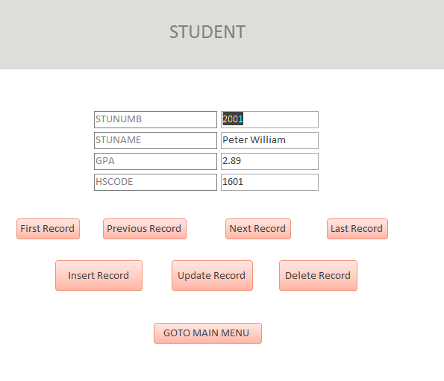

On this form, the user can perform the following operations:

* Navigate to the next, previous, first and last record.
* Insert, update or remove the student.
* Also when the user clicks on the GOTO MAIN MENU button then he can goto the main menu form.
* For inserting the record, the user has to first click the insert button which clears all the fields. After that the user has to enter the new values & click the insert record button again.
* For updating the record, the user has to make sure that the record to be update is displayed in the fields then the user can update the information & click the Update record button.
* For deleting the record, the user has to make sure that the record to be deleted is displayed in the fields then the user can delete the information by clicking the Delete record button.

**Chapter 3 Queries**

1. List the contents of each table.

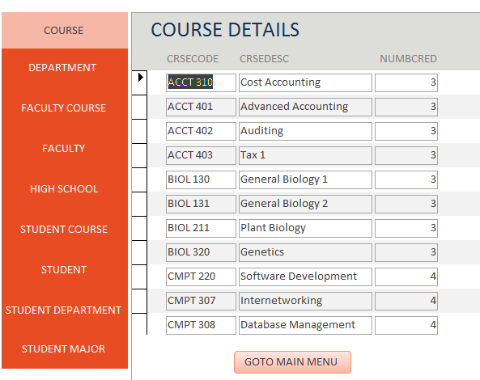

* This form is opened when the user clicks on button given to the first query.
* This form lists all the information present in the database. As shown in the above image user is provided tabs on the left side in vertical order through which user can get the information as per his requirement by clicking on the appropriate tab.

1. Get details of the given faculty.

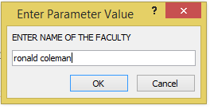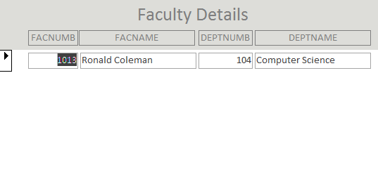

* This form is opened when the user clicks on button given to the second query.
* When the user navigates to this form, he is prompted for input about faculty name. After providing the faculty name, the user gets all the information about that particular faculty.
* For a given faculty name, this query lists the number and name with the number and name of the department to which the faculty member is assigned.

1. Get details of the given student.

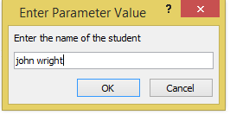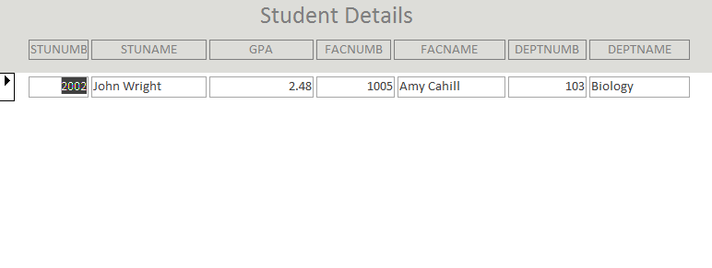

* This form is opened when the user clicks on button given to the third query.
* When the user navigates to this form, he is prompted for input about student name. After providing the student name, the user gets all the information about that particular student.
* For a given student name, this query lists the number, name and the GPA. In addition, for each major the student has, it lists the number and name of the student's advisor and the number and name of the department in which the student is majoring.

1. Get the details of the given high school and current Merriest student details graduated

from that school.

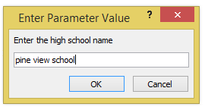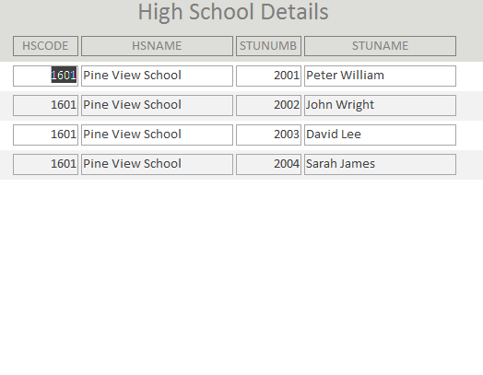

* This form is opened when the user clicks on button given to the forth query.
* When the user navigates to this form, he is prompted for input about high school name. After providing the school name, the user gets all the information about that particular high school.
* For a given high school, this query lists the code and the name with the number and name of all the students at Merriest College who graduated from the high school.

1. Get the details of the given department along with the faculties.

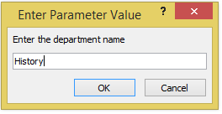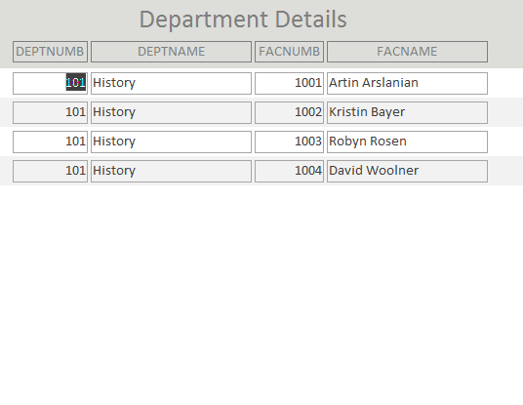

* This form is opened when the user clicks on button given to the fifth query.
* When the user navigates to this form, he is prompted for input about department name. After providing the department name, the user gets all the information about that particular department.
* For a given department name, this query gives the number and name with the number and name of all the faculty members assigned to the department.

1. Get the student details who work for the given department.

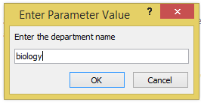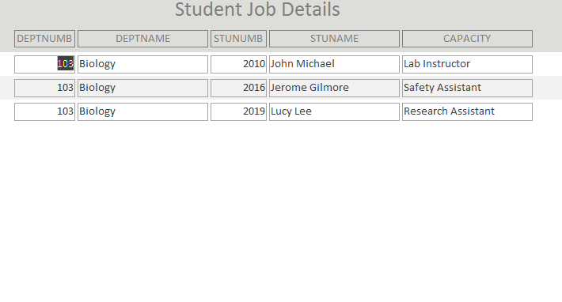

* This form is opened when the user clicks on button given to the sixth query.
* When the user navigates to this form, he is prompted for input about department name. After providing the department name, the user gets all the information about that particular department.
* For a given department name this query lists the number and name with all the students who work for the department and the capacity in which each works. Here capacity states the various types of jobs the student is assigned to.

1. Get the student details advised by the given faculty.

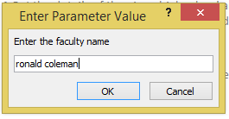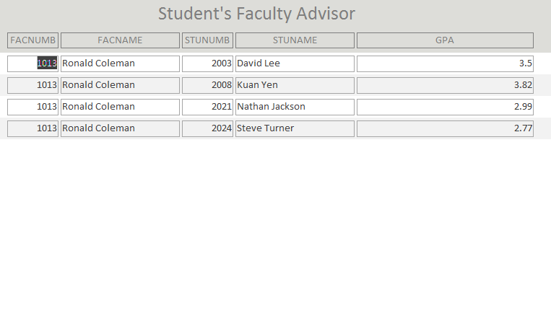

* This form is opened when the user clicks on button given to the seventh query.
* When the user navigates to this form, he is prompted for input about faculty name. After providing the faculty name, the user gets all the information about that particular faculty.
* For a given faculty name, this query lists the number and name with the numbers, names and GPAs of all the students advised by the faculty member.

1. Get the details of the given course along with the assigned professors.

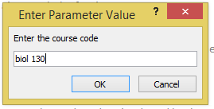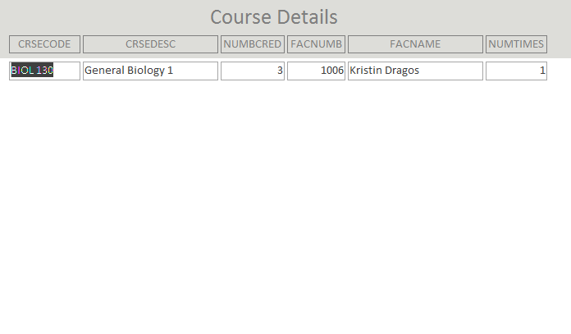

* This form is opened when the user clicks on button given to the eighth query.
* When the user navigates to this form, he is prompted for input about course code. After providing the course code, the user gets all the information about that particular course.
* For a given course name, the query lists the course code, description, and number of credits offered by the course. In addition, for each faculty member who has taught the course, it lists the number and name of the faculty member with the number of times the faculty member has taught the course.

1. Get the full information of the given student.

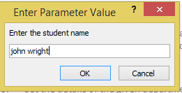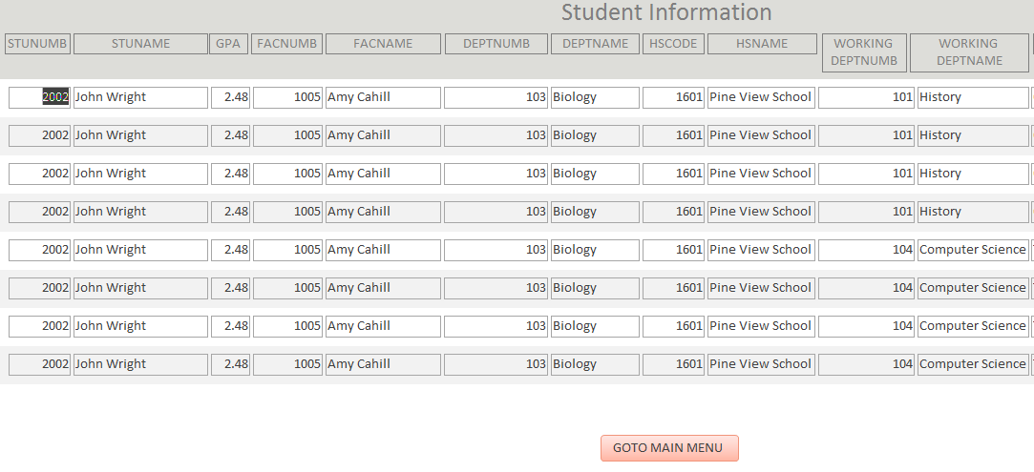

When the user navigates to this form, he is prompted for input about student name. After providing the student name, the user gets all the information about that particular student.

For a given student name, the query lists the number, name, and GPA of the student with:

- The number and name of the student's advisor(s).

- The number and name of each of the departments in which the student is majoring.

- The number and name of the high school from which the student graduated.

- For each department in which the student is working, list the number, the name, and the capacity in which the student works for the department.

- For each course the student has taken, list the number, description, number of credits, and the grade received.

**Chapter 4 Reports**

1. Get details of the each student.

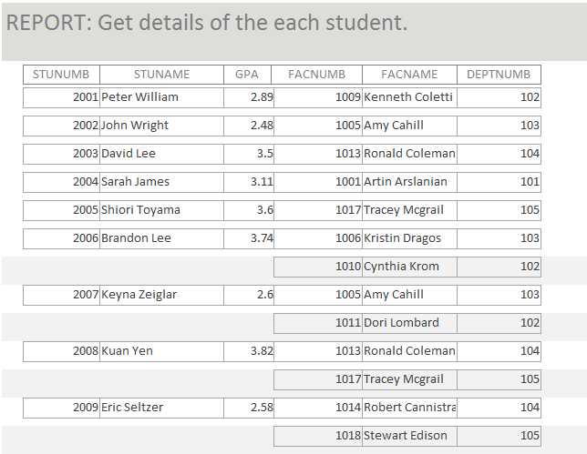

* When the user clicks the generate button corresponding to first report, he gets the report as shown above.
* The report contains the fields which includes: student number, student name, GPA, faculty number, faculty name, department number.

1. Get the details of the each department along with the faculties.

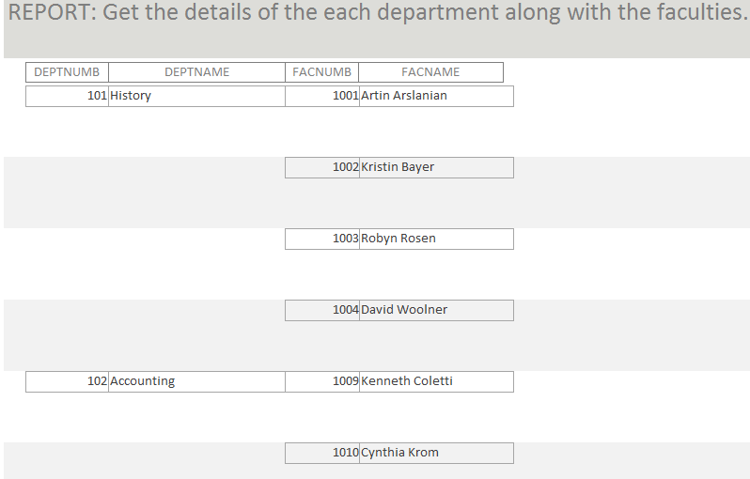

* When the user clicks the generate button corresponding to second report, he gets the report as shown above.
* The report contains the fields which includes: department number, department name, faculty number, faculty name.

1. Get the details of the each course along with the assigned professors.

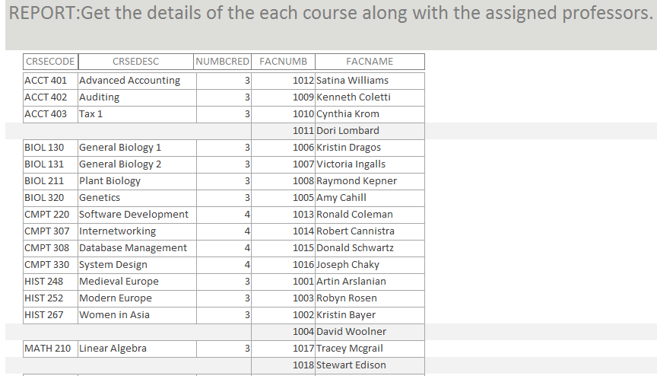

* When the user clicks the generate button corresponding to third report, he gets the report as shown above. The report contains the fields which includes: course code, course description, number of credits, faculty number, faculty name.

1. Get the full information of every student.

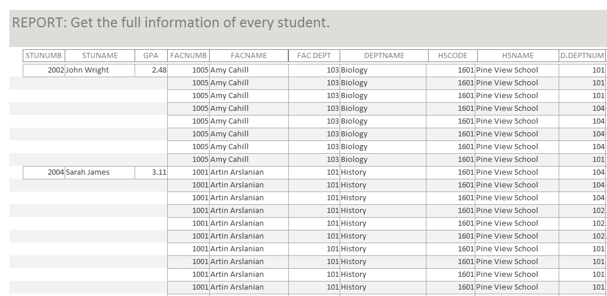

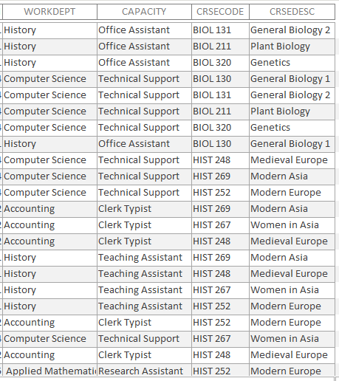

* When the user clicks the generate button corresponding to forth report, he gets the report as shown above.
* The report contains the fields which includes: student number, student name, GPA, faculty number, faculty name, faculty department, department name, high school code, high school name, work department, capacity, course code, course description.